|  |
| --- |
| GAME NAME: Crown and Anchor Game |
| EXAMINER: Hung Ngoc NGUYEN |
| DATE: 20/10/2017 |

|  |  |  |
| --- | --- | --- |
| **REF** | **DESCRIPTION** | **COMMENT** |
| 1 | Game Play: The game will finish if the player balance less than 5 | OK |
| 2 | Player has sufficient balance to place bet | OK |
| 3 | Dice was rolled | OK |
| 4 | Dice showed only one match | OK |
| 5 | Displayed credit balance, bet, and win amount after accounting meters | Fail |

Some errors would be shown by some pictures below:

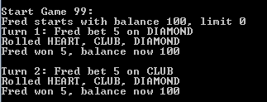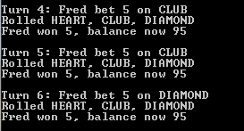

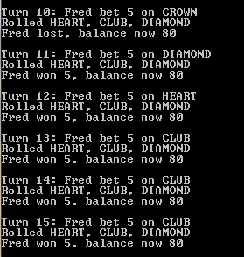

|  |  |  |  |
| --- | --- | --- | --- |
| REF | TESTING | DESCRIPTION | COMMENT |
| 1 | Player won | “Player” and “won” are appeared | OK |
| 2 | One match displayed | Game matches with the roles | OK |
| 3 | The balance | The balance should be displayed the correct result | Fail |